Project Report: Quiz Application Using File Handling in C++

Project By:

Atulit Singh | 17
Dhruav Mathur | 27
Janshrutt Narula | 20
Ashish Ohol | 28

TABLE OF CONTENTS
Introduction
Problem Statement
List of OOP concepts
Explanation of concepts
Output Screenshots
Conclusion

Introduction
The objective of this project is to develop a Quiz Application that allows users to take quizzes, view their scores, and check a leaderboard. Additionally, the application provides administrative functionalities for managing quiz questions and viewing scores. The application uses file handling to store user information and quiz questions, ensuring data persistence across sessions. The
implementation is done in C++ and leverages object-oriented programming (OOP) principles to enhance code organization and reusability.

Problem Statement
In educational settings, quizzes are a common method for assessing knowledge. However, managing quizzes, tracking user scores, and allowing users to register and log in can be cumbersome without a systematic approach. The project aims to address the following problems:
- User Management: Allow users to register, log in, and view their scores.
- Quiz Management: Enable the admin to add, delete, and manage quiz questions.
- Score Tracking: Maintain a leaderboard to track user scores.
- Data Persistence: Store user and quiz data in files to ensure that information is retained between sessions.

List of OOP Concepts Used in This Project

Classes and Objects:
  - The application defines multiple classes (student, question, and admin) to
encapsulate related data and functionalities. Each class represents a specific entity in the application.

Encapsulation:
  - Data members of classes are made private or protected, and public methods are
provided to access and modify these members. This helps in protecting the integrity of the data.

Inheritance:
  - The question class inherits from the student class, allowing it to access protected members and methods, promoting code reuse.

Static Members:
  - Static members (e.g., current_score in the student class) are used to maintain shared data across all instances of a class. This is useful for tracking scores that are not tied to a specific user instance.

Method Overloading:
  - The application uses method overloading to provide multiple versions of methods (e.g., setdata and setalldata in the student class) that accept different parameters, enhancing flexibility.

Data Abstraction:
  - The implementation abstracts complex operations (e.g., file handling, score
calculations) behind simple method calls, making the code easier to understand and use.

Explanation of Key Components

Student Class
  - Functionality: Manages user registration, login, and score tracking.

Methods:
    - register_new_user(): Registers a new user and stores their information in a file.
    - login(): Authenticates the user based on username and password.
    - leaderboard(): Displays the leaderboard by sorting users based on their scores.

Question Class
  - Functionality: Handles quiz question management.

Methods:
    - get_new_question(): Prompts the admin to enter a new question and its options.
    - takequiz(): Facilitates the quiz-taking process, including displaying questions and recording answers.
    - getquestions(): Reads questions from a file and returns them as a vector.

Admin Class
  - Functionality: Provides administrative capabilities for managing quiz questions and viewing scores.

Methods:
    - addquestions(): Allows the admin to add new questions to the quiz.
    - removequestions(): Enables the admin to delete a specific question from the quiz.
    - viewscores(): Displays scores of all users.

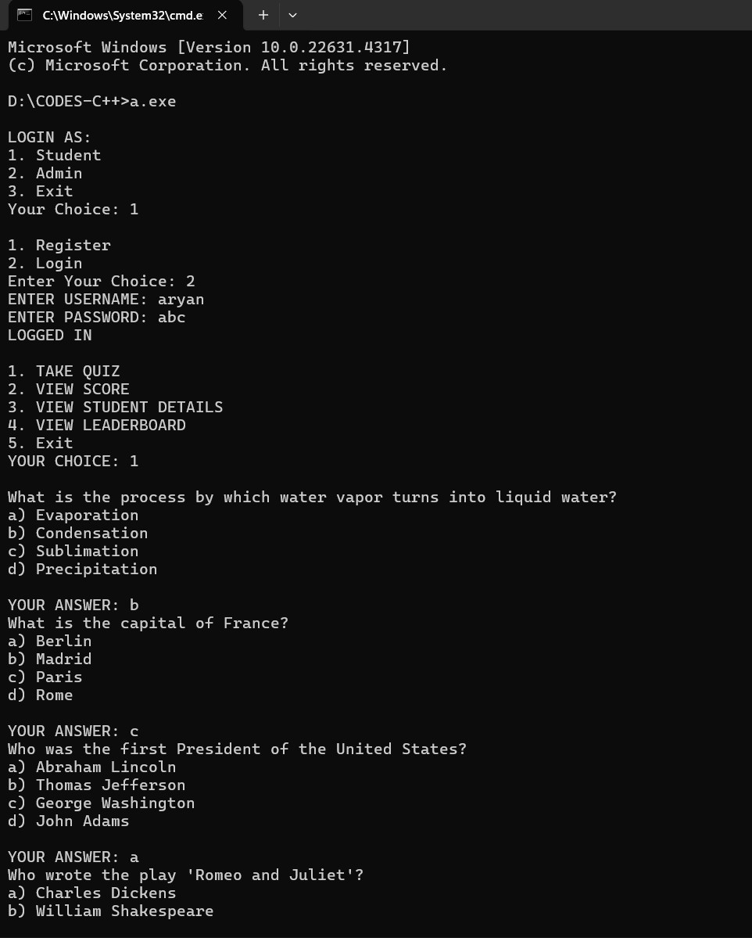

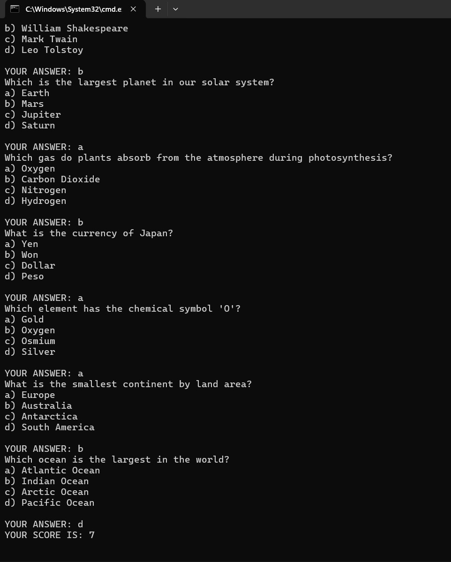

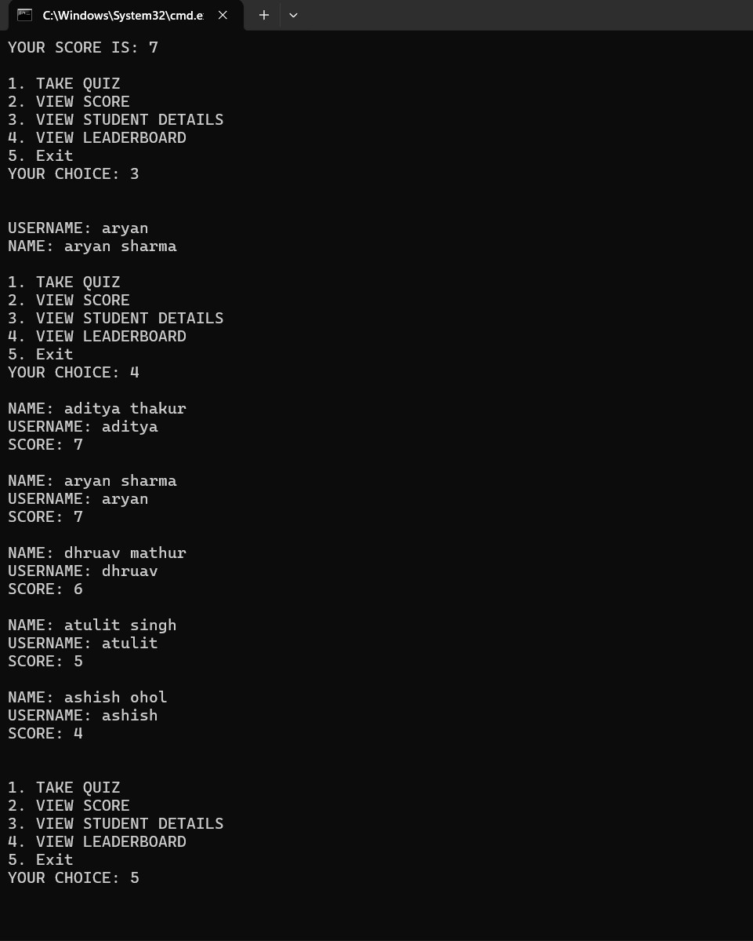

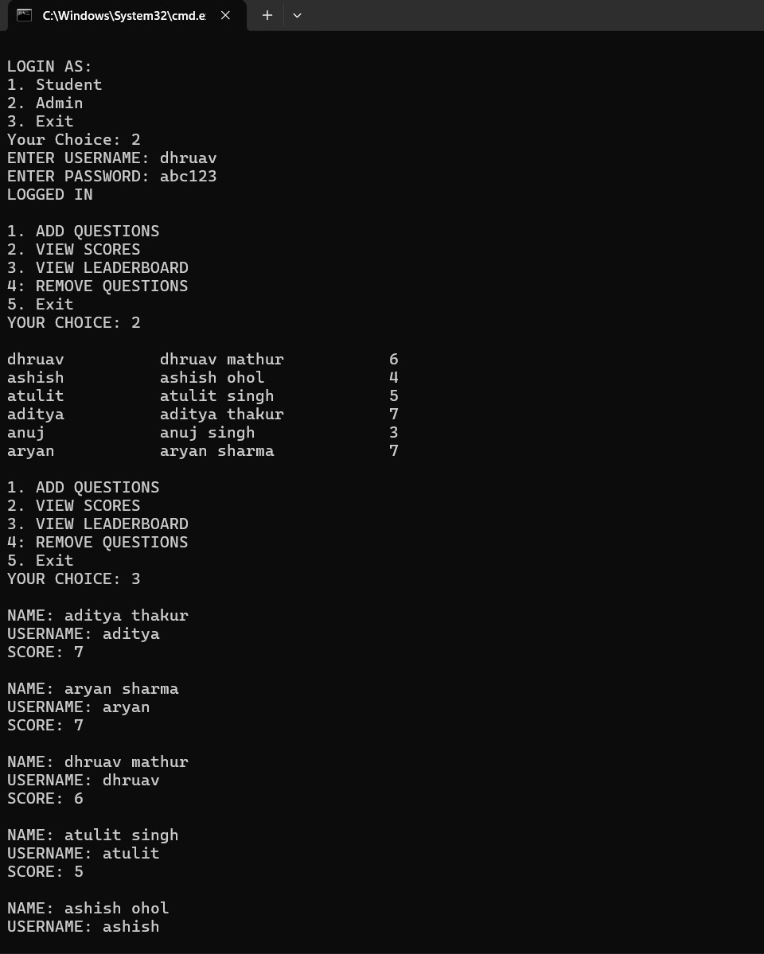

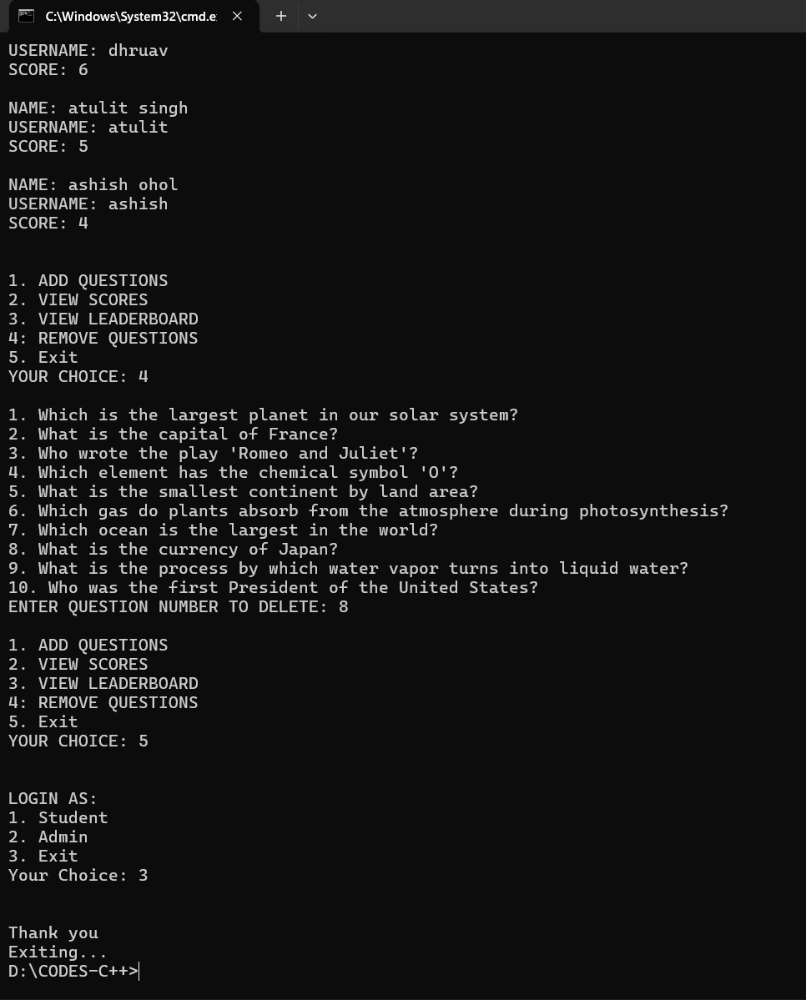

Conclusion
The Quiz Application effectively demonstrates the use of object-oriented programming principles to create a functional and maintainable software solution. By utilizing file handling for data persistence, the application provides a seamless experience for both users and administrators. This project not only addresses the problem of managing quizzes but also serves as a practical example of applying OOP concepts in C++. Future enhancements could include adding more features, such as timed quizzes, user feedback, and a graphical user interface (GUI).

